**Video provides a powerful way to help you prove your point. When you click Online Video, you can** *paste in the embed code for the video you want to add. You can also type a keyword to search online* for the video that best fits your document.

To make your document look professionally produced, Word provides header, footer, cover page, and ~~text box designs that complement each other. For example, you can add a matching cover page,~~ ~~header, and sidebar. Click Insert and then choose the elements you want from the different galleries.~~

Themes and styles also help keep your document coordinated. When you click Design and choose a new Theme, the pictures, charts, and SmartArt graphics change to match your new theme. When you apply styles, your headings change to match the new theme.

H2O

(A2+B2)

JATIN SINGH

JATIN SINGH

JATIN SINGH

Video provides a powerful way to help you prove your point. When you click Online Video, you can paste in the embed code for the video you want to add. You can also type a keyword to search online for the video that best fits your document. To make your document look professionally produced, Word provides header, footer, cover page, and text box designs that complement each other.

Video provides a powerful way to help you prove your point. When you click Online Video, you can paste in the embed code for the video you want to add. You can also type a keyword to search online for the video that best fits your document. To make your document look professionally produced, Word provides header, footer, cover page, and text box designs that complement each other.

Video provides a powerful way to help you prove your point. When you click Online Video, you can paste in the embed code for the video you want to add. You can also type a keyword to search online for the video that best fits your document.

GROCERY LIST

* Atta 20kg
* Rice 25kg
* Tea 1kg
* Coffee 250g
* Moong pluses
* Spices 100g

CLOTHING LIST

1. 1 Hoddy
2. 2 full Sleeve t-shirt
3. 1 running tracksuit

VIDEO PROVIDES A POWERFUL WAY TO HELP YOU PROVE YOUR POINT. WHEN YOU CLICK ONLINE VIDEO, you can paste in the embed code for the video you want to add. you can also type a Keyword To Search Online For The Video That Best Fits Your Document. To Make Your Document LOOK PROFESSIONALLY PRODUCED, wORD PROVIDES HEADER, FOOTER, COVER PAGE, AND TEXT BOX DESIGNS THAT COMPLEMENT EACH OTHER.

VIDEO PROVIDES A POWERFUL WAY TO HELP YOU PROVE YOUR POINT. WHEN YOU CLICK ONLINE

VIDEO, you can paste in the embed code for the video you want to add. you can also type a

**Video provides a powerful way to help you prove your point. When you click Online Video, you can paste in the embed code for the video you want to add.**

**Video provides a powerful way to help you prove your point. When you click Online Video, you can paste in the embed code for the video you want to add.**

|  |  |  |  |  |  |  |
| --- | --- | --- | --- | --- | --- | --- |
|  | | | | | | |
|  |  |  |  |  |  |  |
|  |  |  |  |  |  |
|  |  |  |  |  |  |



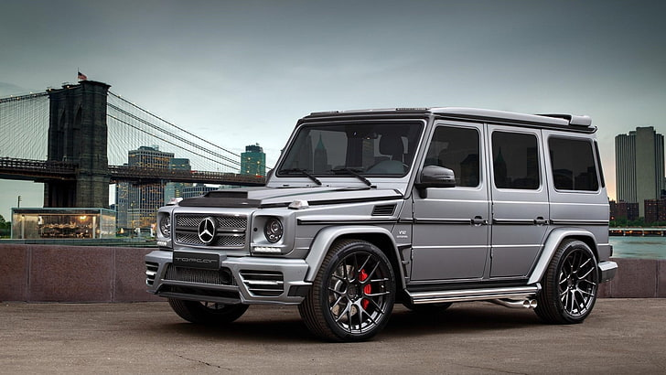



[typingstudy](https://www.typingstudy.com/)

# Introduction

Artificial Intelligence is a method of making a computer, a computer-controlled robot, or a software think intelligently like the human mind. AI is accomplished by studying the patterns of the human brain and by analyzing the cognitive process. The outcome of these studies develops intelligent software and systems.

# Summary

Artificial intelligence is a constellation of many different technologies working together to enable machines to sense, comprehend, act, and learn with human-like levels of intelligence.

# Syllabus

The curriculum covers various areas such as Machine Learning, Deep Learning, Natural Language Processing, Computer Vision, Robotics, Data Science, and core concepts of Algorithms and Data Structures.

# Conclusion

Ultimately, the end goal of AI is to enhance human lives, improve efficiency, and address complex challenges across various fields, ranging from healthcare and education to business and environmental sustainability.